**Database Development and Class Registration**

Rodrigo Cruz

CST 499 Capstone for Computer Software Technology

Instructor: Charmelia Butler

10/17/2023

As the class winds up, the creation of this final project has been fun and a good challenge at the same time. I have been able to complete this project through trial and error as different pages were created and connected to their perspective databases. I enjoyed working on this project as I have been able to learn many things I did not know and also it has helped me understand that I still have many things to learn as I prepare myself for a new career. I will be going over my experience during the implementation phase and some of the challenges I encountered as I developed each stage of the project.

Week three was the beginning of this project with a registration page and a login page that directs you to the landing page. For week four we were tasked with creating the different tables that were going to be used for this project, including semester, enrollment, classes, and students. We were also tasked with creating the different pages that will be used for this project. The first thing I did was to work on the different pages including the enrollment page, and the class drop page, I also used Bootstrap to help me with the appearance of each page and the different functions. On each page, I included my config. Page using the include function which creates the linkage to the database. Each page was also linked to the perspective table by using the insert mysqli, feature to the name of the table where that data was intended to be inserted. I also created different classes on each page depending on what message needed to be shown. I also made some modifications using other examples to make it look more pleasing and professional.

Some of the challenges I faced was getting the colors I wanted and modifying the way the page looked on the css style sheet as I wanted to ensure the page looked presentable and professional. I also encountered errors multiple times when linking the database tables due to either missing characters or missing parts of the code. Below are some screenshots of the project put together as well as the different database tables and the codes for some of the different pages being presented.

Student registration log.

Class log with the option to remove.

Student class enrollment.

Student registration page with student ID.

Semester Page.

Student table.

Semester Table.

Class table.

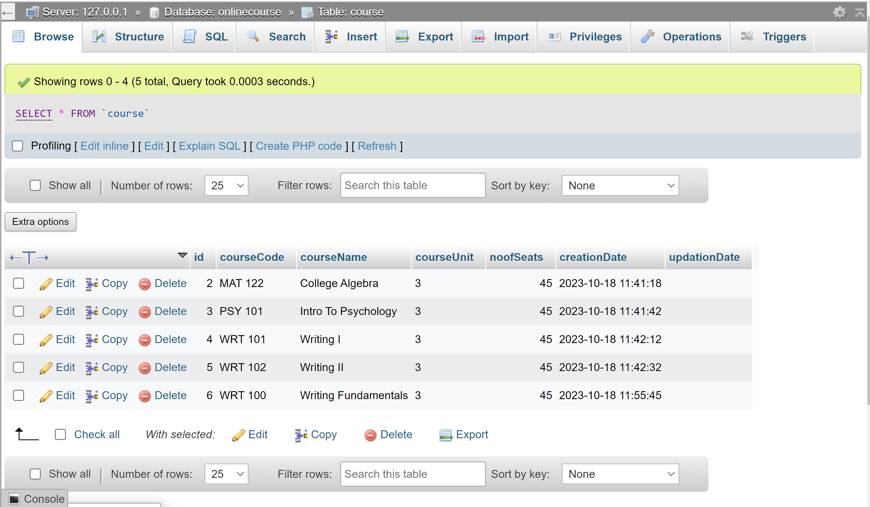

Enrolment Class table.

Enrollment, semester, and class codes.

References:

Journal, I. (2014). A Framework for Web Based Student Record Management System using PHP. *Ijcsmc*. <https://www.academia.edu/7853090/A_Framework_for_Web_Based_Student_Record_Management_System_using_PHP_>

*PHP and SQL made simple*. (2005, August 1). IEEE Journals & Magazine | IEEE Xplore. https://ieeexplore.ieee.org/abstract/document/1510592